|  |  |  |  |  |  |
| --- | --- | --- | --- | --- | --- |
| Date | 24-Nov-22 | | | Tester Name | Mayuri Patel |
| Environment | Penfax - Test | | | Login used |  |
| Operating System | Select OS | Version: | Update: | | |
| Software Used | Select Software | Version: | Update: | | |
| Select Software | Version: | Update: | | |
| Release version | 22.4.1 | | | | |
| Title |  | | | | |
| Test Type | Regression | | | | |
| Test Scenario | Add a trustee for a MEPP Beneficiary | | | | |
|  |  | | | | |
| Expected Results |  | | | | |
| Pass/Fail | Pass | | | JIRA# | N/A |

Describe your steps with screenshots:

Search for any MEPP member that do not have “trustee” beneficiary listed yet. (If trustee is already there as beneficiary then new trustee will be added as beneficiary creating two trustees as beneficiary on the person profile)

Open that member profile.

Under person profile, beneficiary tab🡪beneficiary Designations

Add beneficiary Designation

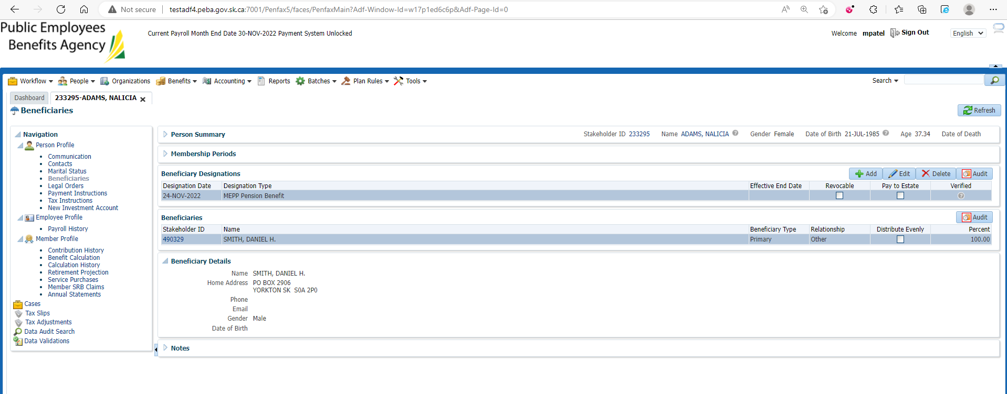

Add beneficiary details or search for beneficiary

Here, new beneficiary details are added and then save the details

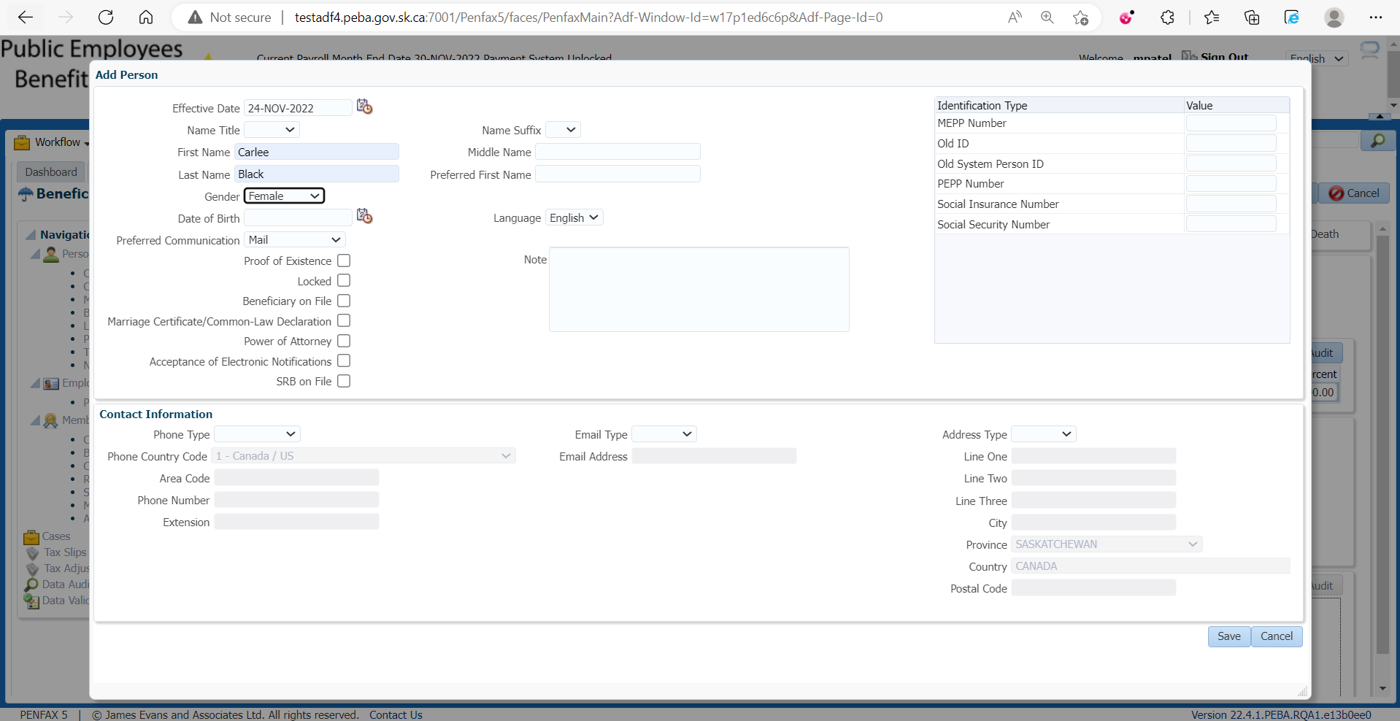

Add Beneficiary Type🡪 Trustee, Relationship and then save the details

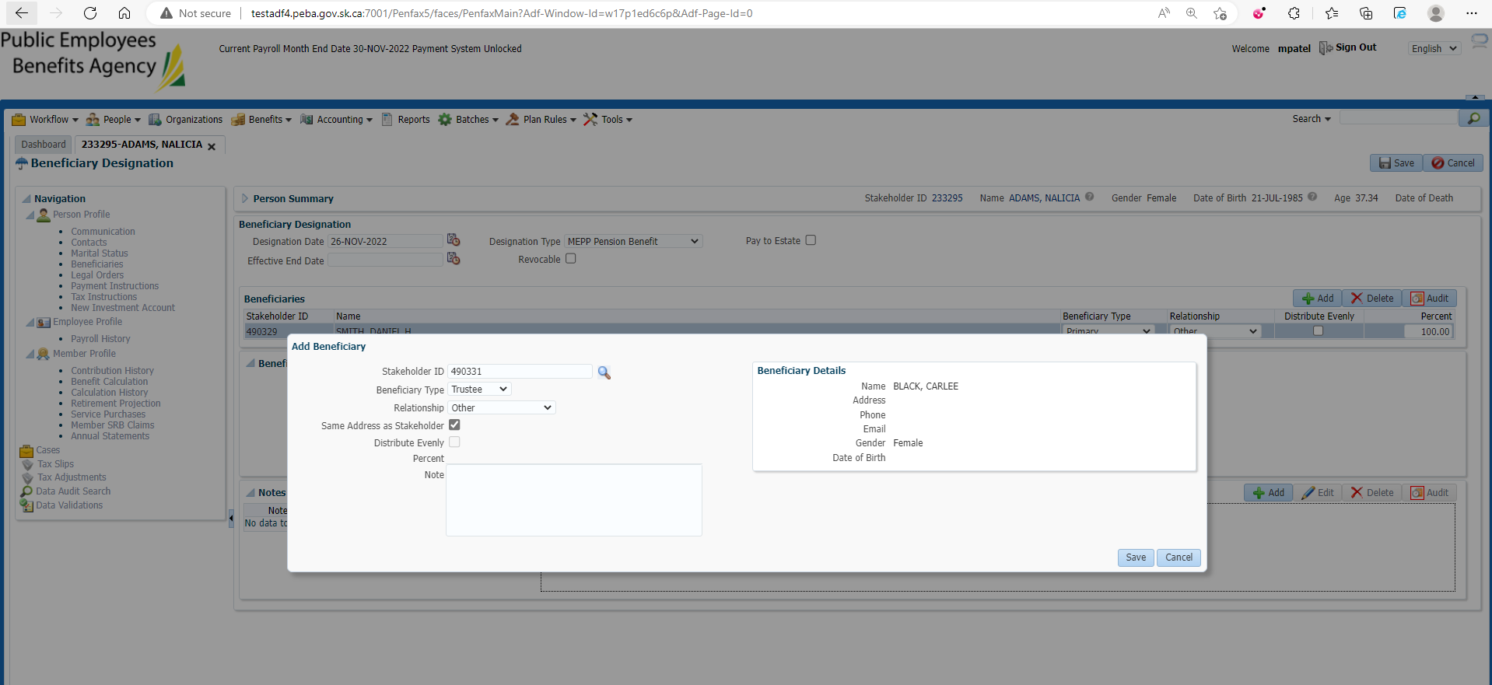

Enter Designation Date, Designation Type and hit save button at the top right corner

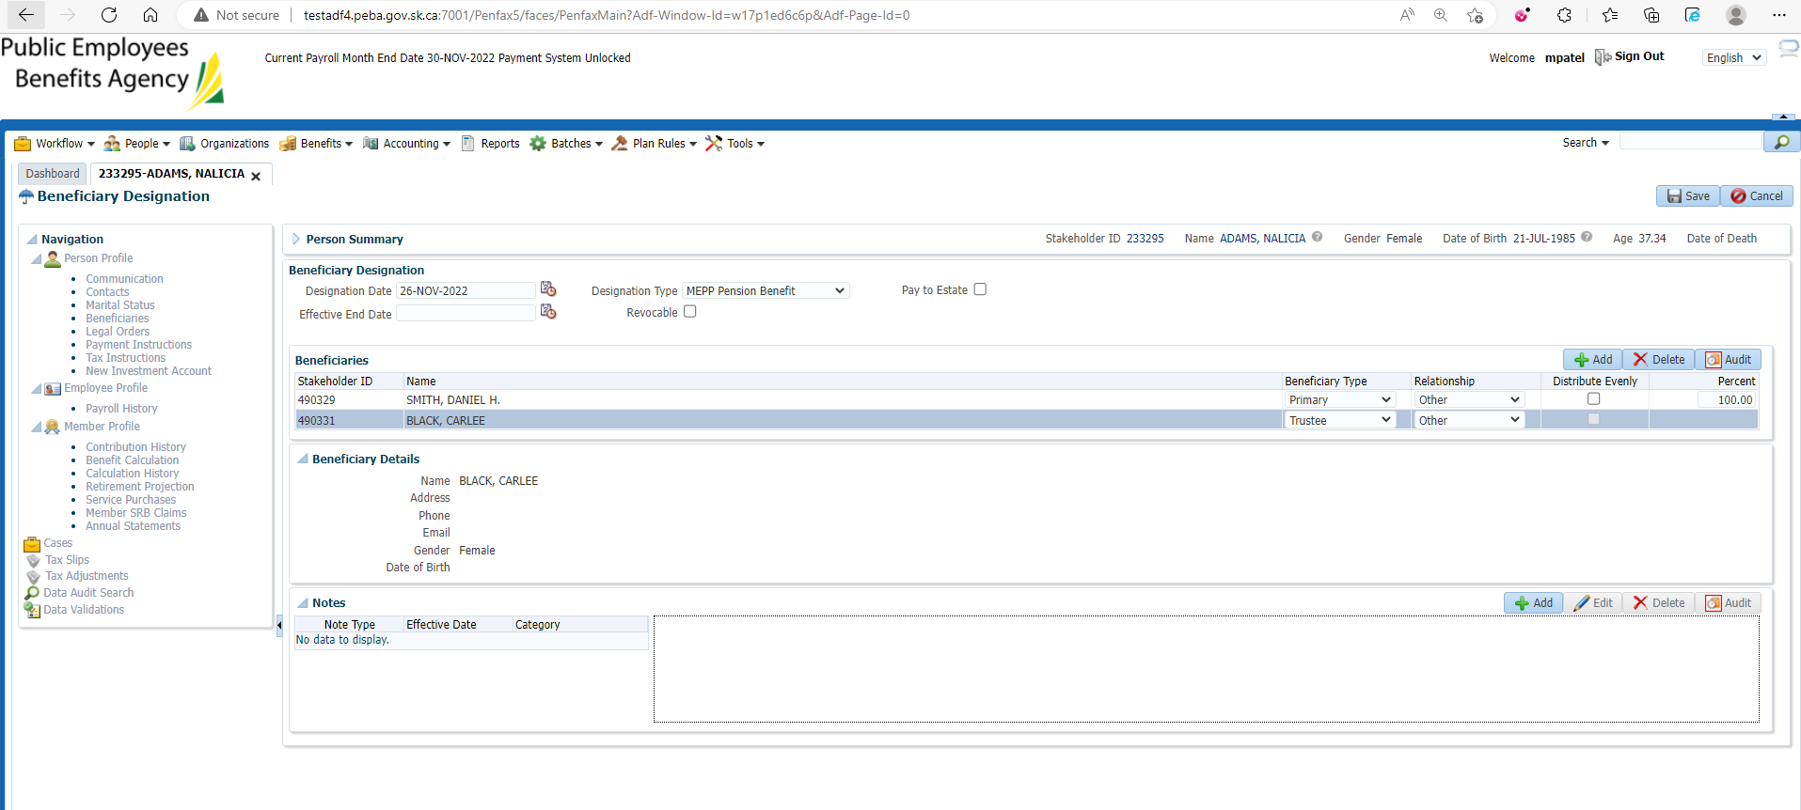

New Trustee beneficiary is added

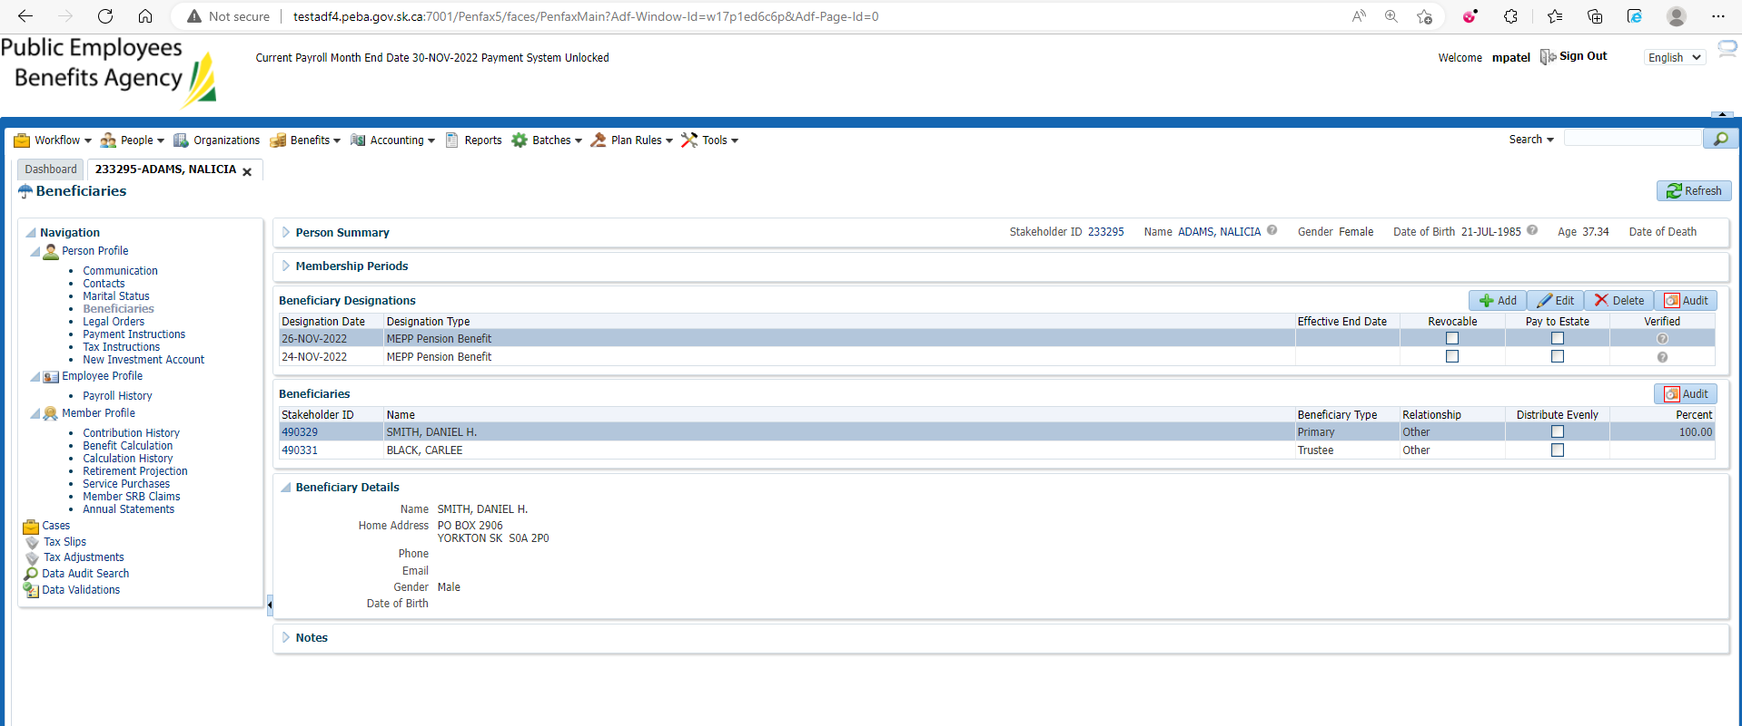

Changes are reflected in Penweb

